A SIMPLE FFT-BASED PERCEPTUAL AUDIO SYNTHESIS
USING THE MP3 PSYCHOACOUSTIC MODEL

Project Description
A step-by-step procedure that summarizes the project is shown in Fig. 1.
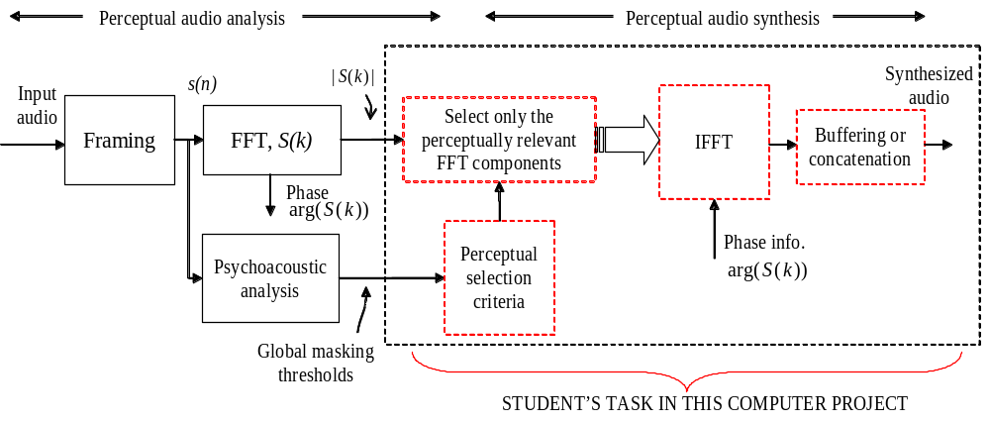
Fig. 1. Perceptual audio analysis/synthesis

A 16-bit pulse code modulated (PCM), 44.1 kHz sampled input audio is first read using the “wavread” command in MATLAB. The input audio is then segmented into frames of 512 samples. Next, a 512-point FFT is performed on the current audio frame to compute both the magnitude spectrum and the phase. Psychoacoustic analysis is performed in parallel to estimate the global masking thresholds. Our objective is to discard some of the FFT components estimated in the FFT analysis based on perceptual criteria. The global masking thresholds computed from the psychoacoustic analysis can serve as a potential metric for the perceptual audio synthesis or reconstruction. In fact, an extended model of this metric has been successfully integrated into a variety of audio compression standards. The perceptually-based FFT component selection criteria that we employ in this project is a rather simple one, i.e., “If the FFT magnitude spectrum of the input audio (in dB) falls below the global masking threshold (in dB), then we will discard these FFT components, simply, by setting the values of the FFT spectrum components to be -100 dB.” (Consider only the first 256 components of the FFT magnitude spectrum for comparison and to discard; Recall from your earlier MATLAB exercise, the mirror conjugate symmetry properties of the FFT magnitude spectrum). Next, the resulting modified FFT magnitude spectrum must be combined in an appropriate manner with the phase. It is important that the conjugate symmetry of the spectrum is preserved. We will then perform a 512-point inverse FFT (IFFT) to synthesize the input audio frame. Finally, a buffer is employed to concatenate all these audio frames to reconstruct the audio signal.

MATLAB FILES and programming hints
Please obtain the following three MATLAB files from the course website: psymain.m, psychoacoustics.m, and audio_synthesis.m. Also, obtain the audio file “ch5_music.wav.” Please make sure that you have saved all these files under the same directory.
1. psymain.m : This MATLAB file is the main file that contains the complete flow of your project. In other words, it embeds in it all the blocks shown in Fig. 1.
2. psychoacoustics.m : This file contains the five steps of the psychoacoustic analysis described in the audio book.
3. audio_synthesis.m : This is the only MATLAB program that the student will develop. A helpful skeleton is provided and instructions to complete the programming task is given later in this section.

Part-A Audio analysis : This part is made available to the students.
- Input audio file read : An input audio sampled at 44.1 kHz and digitized using a 16-bit pulse code modulation (PCM) is provided, i.e., ch5_music.wav. Use,
[s, fs, bits] = wavread(‘ch5_music.wav’);
to read the wave file (verify that fs = 44100 and bits = 16). This task is performed in the psymain.m.
- Framing : We will use a frame size of 512 samples; Or, in the time domain, the frame size = (512 samples)/(44.1 samples per second)= 11.61 ms. This task is done in the psymain.m.
- FFT : An FFT analysis is performed on each frame in order to estimate the FFT magnitude spectrum and the phase information. We will use an FFT size of 512. This task is included in the psymain.m.
- Psychoacoustic Analysis : Global masking thresholds (in dB) and the power spectral density (in dB) are the two parameters estimated in this MATLAB function. Please note that this function performs the core of the psychoacoustic analysis and the algorithmic details are given in the book, Chapter 5.

Part-B Audio Synthesis : This programming task has to be performed by the students.
- Perceptual selection criteria : The selection criterion you must use is, if the FFT magnitude spectrum of the input audio (in dB) is less than the global masking threshold (in dB), then set the values of the FFT magnitude spectrum components to be -100 dB.
--------------------------------------In Audio_synthesis.m---->>>> (Task I-A)
FOR ALL THE FFT COMPONENTS FROM 1 TO (length(PSD))
IF ( PSD(i) < THR_GLOBAL(i) )
PSD(i) = -100;
END
END
------------------------------------------------------------->>>>
- Perform FFT component selection : Next perform the following arithmetic operation to convert the PSD from dB sound pressure level to the FFT magnitude,
------------------------------------ In Audio_synthesis.m ---->>>> (Task I-B)
Mag = (10.^((PSD - 90.302)/10)).^(0.5);
% (SEE CHAPTER 5 FOR DETAILS ON DB SPL CONVERSION)
------------------------------------------------------------->>>>
- IFFT : You will need to combine the phase with the PSD value and then perform the IFFT
-------------------------------------- In Audio_synthesis.m -->>>> (Task I-C)
i) ESTIMATE THE PHASE
ii) COMBINE THE PHASE WITH THE PSD, i.e., 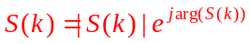
iii) CONCATENATE THE MIRROR IMAGE (THE FLIPPED VERSION) OF THE FFT WITH ITSELF. (HINT: YOU CAN USE FLIPUD() OR FLIPLR() COMMANDS IN MATALB TO REVERSE OR FILP A VECTOR)
------------------------------------------------------------->>>>
------------------------------------- In Audio_synthesis.m -->>>> (Task I-D)
iv) NEXT, PERFORM THE IFFT
------------------------------------------------------------->>>>
- Buffering : This task is included in the Psymain.m. You must concatenate all the synthesized audio frames from the file Audio_synthesis.m into a single vector, i.e., Output_audio is the variable.

